Requirements for ShaadiSaga

1. Vendors

1. Photographers

* Title : string
* Photographer place : string
* Rate : float
* Reviews : int
* Banner : image file
* Working since : int
* Travel policy : string

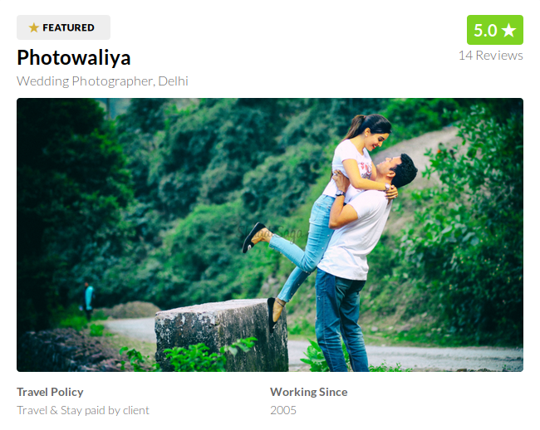

title, photographer place, rate, reviews, banner, travel policy, working since

* Introduction : string



* Services & Pricing
  + service name : string
  + price : int
  + description : string

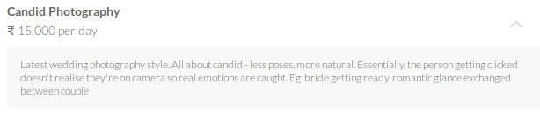service name, price, description

* + payment policy : string



* + cancellation policy: string



* Past Work – Photos & Videos
  + title : string
  + count : int
  + banner : image file
  + video : video file

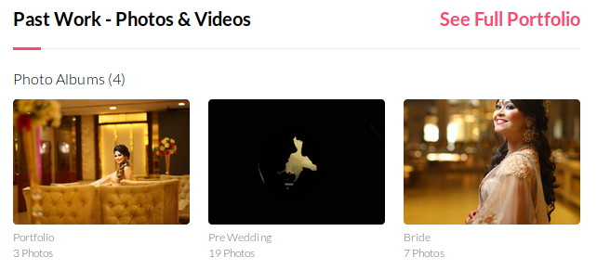

1. Makeup Artists
   * + Same as Photographer
     + Additional
       - Services & Pricing
         1. Trial Makeup (title: string, description: string)
         2. Can do makeup at (title: string, description: string)
         3. Travel Policy (title: string)

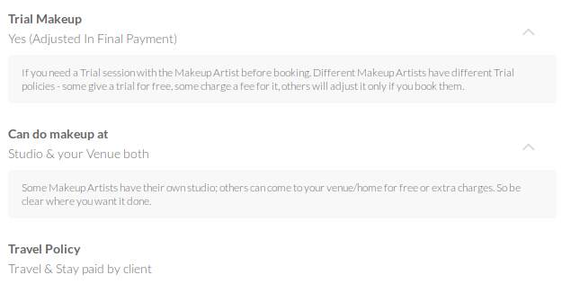trial makeup, can do makeup at, travel policy

1. Decorators
   * + Same as Photographer
     + Additional
       - Core Speciality : string



1. Venue
   * + Title : string
     + Reviews : int
     + Rate : float
     + Place : string
     + Per plate : int

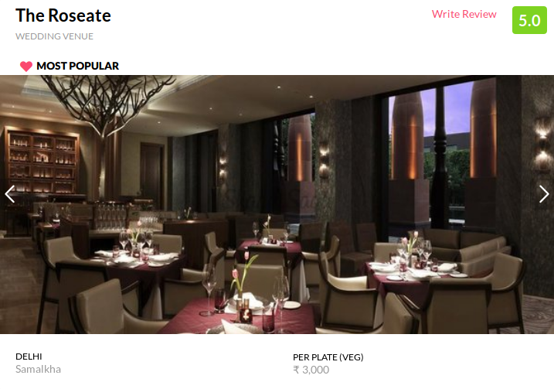title, reviews, rate, place, per plate

* + - About us : string
    - Property type : string

about us, property type

* + - Services & Pricing
      * service name : string
      * price : int
      * food policy : string
      * décor policy : string
      * djpolicy : string
      * payment policy : string

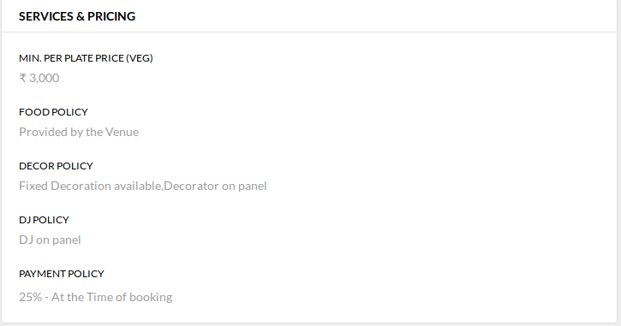service name, price, food policy, décor policy, djpolicy, payment policy

* + - Gallery
      * title : string
      * count : int

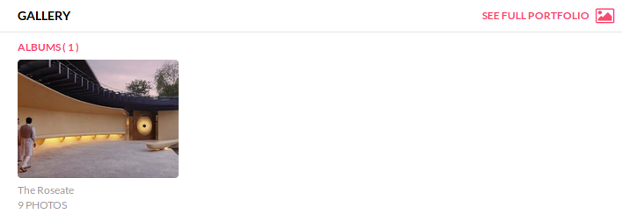

1. Mehndi Artists
   * + Same as Photographer
2. Choreographers
   * + Same as Photographer
     + Additional
       - Specializations : string
       - Qualifications : string
       - Starting Price
         1. price : int
         2. description : string

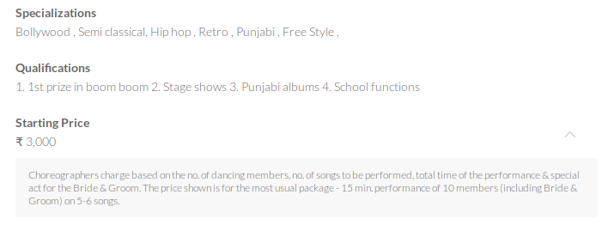

1. Wedding Invitations
   * + Same as Photographer
     + Additional
       - Unboxed Cards : string
       - Boxed Cards : string
       - Our Speciality : string

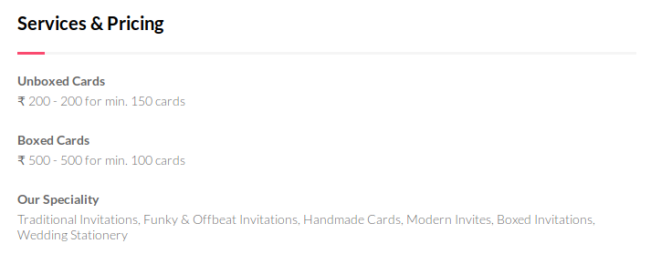

1. Bridal Designers
   * + Title : string
     + Reviews : int
     + Rate : float
     + Banner : image file
     + Place : string
     + Range : string

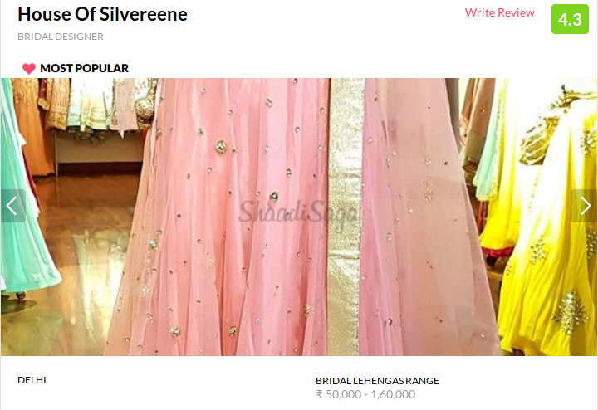

* + - About us : string
      * store type : string
      * speciality : string

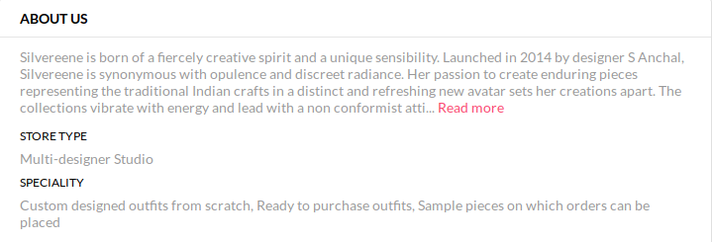

* + - Services & Pricing
      * service name : string
      * price : string



* + - Payment policy : string



* + - Gallery
      * title : string
      * count : int

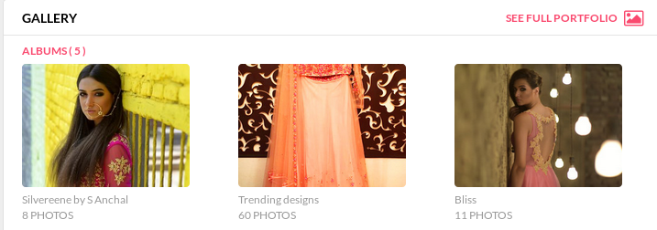

1. Videographers
   * + Same as Photographer
     + Additional
       - Services & Pricing
         1. Candid Photograph (price: int, description: string)
         2. Traditional Photograph : (price: int, description: string)
         3. Cinematic Videography : (price: int, description: string)
         4. Pre-Wedding Shoot : (price: int, description: string)

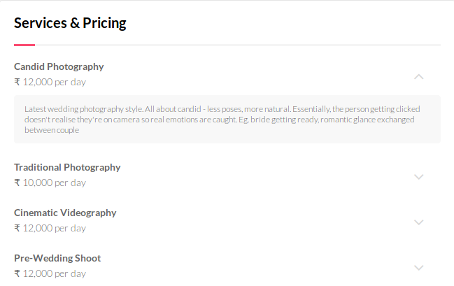

1. Wedding Planners
   * + Same as Photographer
     + Additional
       - Planning Type : string



* + - * Services & Pricing
        1. Services Provided : string
        2. In House Services : string
        3. Planning Type : string

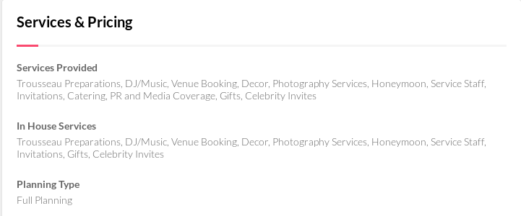

2. Blog

1. Bridal Fashion +

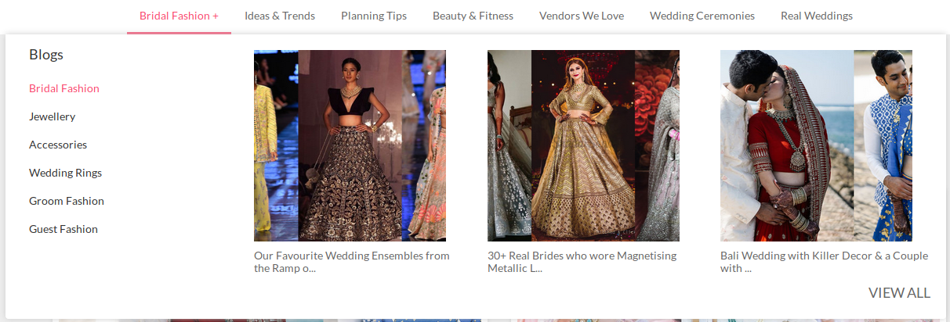

1. Ideas & trends

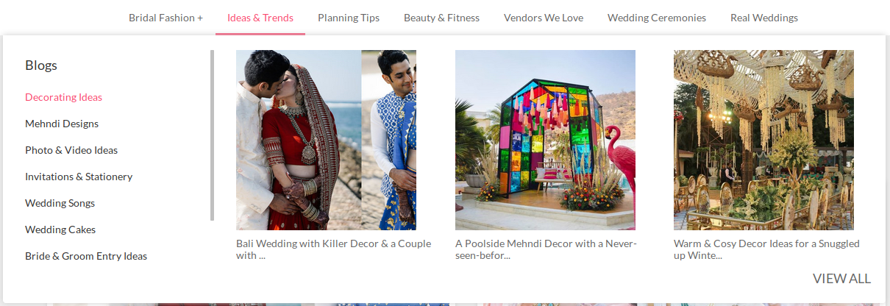

1. Planning Tips

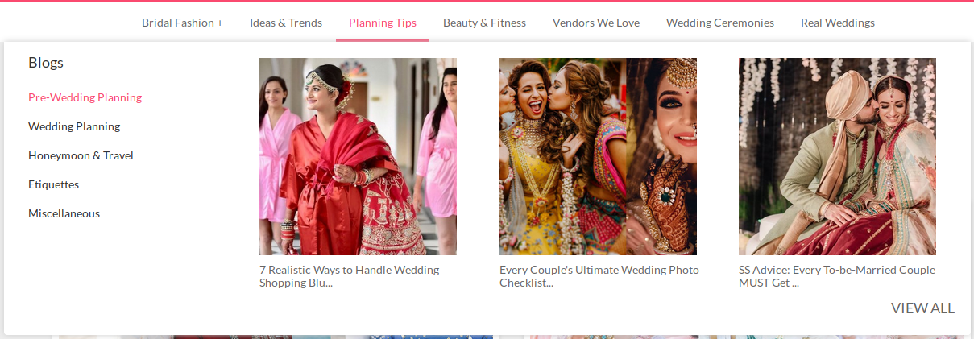

1. Beauty & Fitness

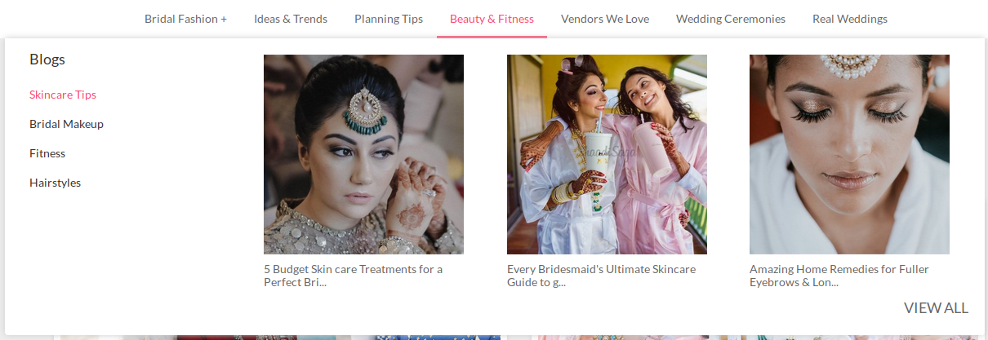

1. Vendors We Love

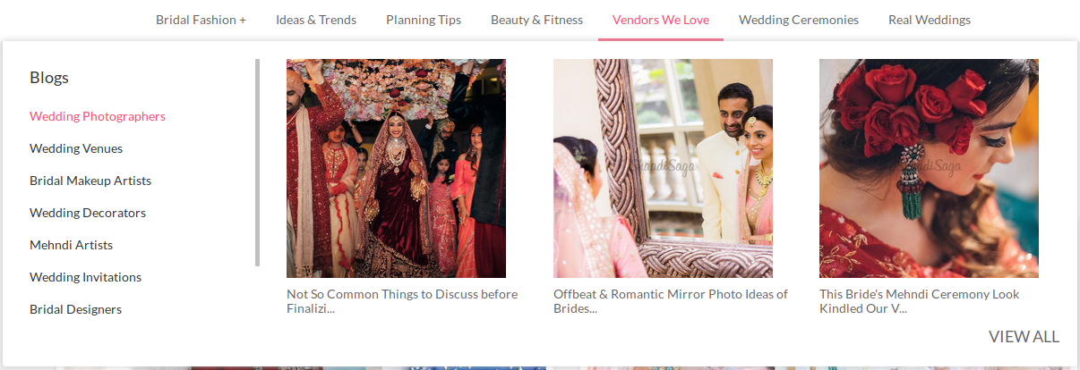

1. Wedding Ceremonies

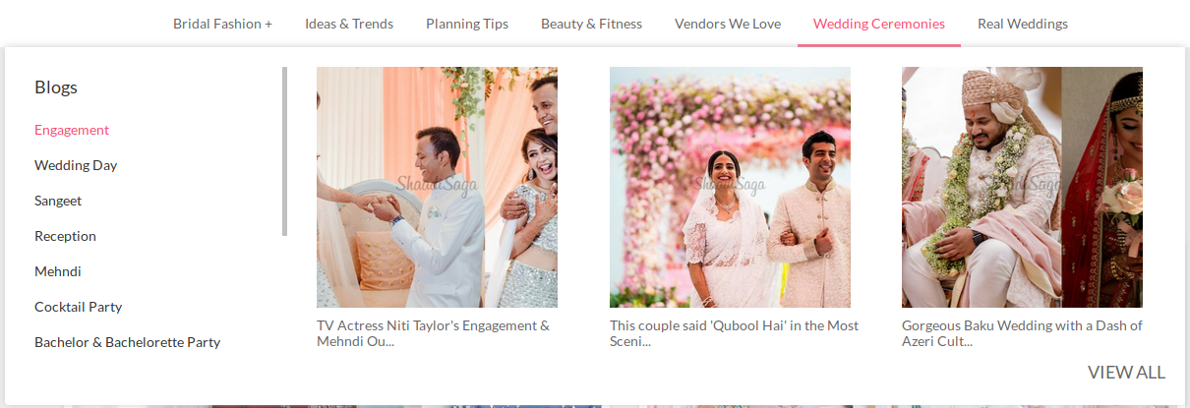

1. Real Weddings

